C:\Users\anreinhardt\Desktop\Logo_FAPS.wmfDevelopment of A Parametric Tool for Automated

Slot Insulation Insertion in Small-Scale Electric-

Motor Stator Production

Project Thesis in study program Electromobility ACES

Friedrich-Alexander-Universität Erlangen-Nürnberg  
Lehrstuhl für Fertigungsautomatisierung und Produktionssystematik  
Prof. Dr.-Ing. Jörg Franke

Hier aussagekräftiges Bild einfügen, welches den Inhalt der Arbeit

darstellt. Bild vor den Text positionieren, um ein Verschieben der unteren Angaben zu

verhindern (Rechtsklick auf Bild, Zeilenumbruch, hinter den Text).

Bildbreite: 16,88 cm (bündig mit Logo)

Bearbeiter: Alen Sebastian, 23221507

Betreuer: Prof. Dr.-Ing. Jörg Franke  
 Valentin Henrich

Abgabetermin: 31.08.2025  
Bearbeitungszeit: 6 Months

Erklärung

Ich versichere, dass ich die Arbeit ohne fremde Hilfe und ohne Benutzung anderer als der angegebenen Quellen angefertigt habe und dass die Arbeit in gleicher oder ähnlicher Form noch keiner anderen Prüfungsbehörde vorgelegen hat und von dieser als Teil einer Prüfungsleistung angenommen wurde. Alle Ausführungen, die wörtlich oder sinngemäß übernommen wurden, sind als solche gekennzeichnet.

Erlangen/Nürnberg, den XX.XX.202X

Alen Sebastian

ABSTRACT

The customer specific manufacturing of stators for electric motors in small-scale production is based on a time-consuming and expensive process chain. For this reason, the Institute for Factory Automation and Production Systems (FAPS) from Friedrich-Alexander University Erlangen-Nuremberg (FAU) is researching on solutions centered on the flexible automation of these processes. This paper presents a parametric mechanical tool designed for the robotic-based insertion of slot insulation paper in electric motors. While this task is predominantly performed manually in small-scale production, the proposed tool offers a flexible solution for automation. The tool's parametric design supports fast customization for different stator variants. Given the limited profit margin, the cost-efficiency of the solution is a key factor in its development. The main goal is to improve flexibility in assembling different variants, small batch sizes and customer specifications.

Table Of Contents

[ABSTRACT 4](#_Toc206097485)

[Table Of Contents I](#_Toc206097486)

[1 Introduction and objectives 6](#_Toc206097487)

[1.1 Motivation 6](#_Toc206097488)

[1.2 Vision 8](#_Toc206097489)

[1.3 Problem Statement 8](#_Toc206097490)

[1.4 Structure of the thesis 8](#_Toc206097491)

[2 Fundamentals of Electric Motor Production 9](#_Toc206097492)

[2.1 Motor Types and Construction Principes 9](#_Toc206097493)

[2.1.1 Synchronous Motors 9](#_Toc206097494)

[2.1.2 Asynchronous Motors 9](#_Toc206097495)

[2.2 Stator Assembly 10](#_Toc206097496)

[2.3 Rotor Assembly 12](#_Toc206097497)

[2.4 Slot liner function and Importance 13](#_Toc206097498)

[3 Robotic Systems for Insertion Tasks 15](#_Toc206097499)

[3.1.1 Suitable Robot Types 15](#_Toc206097500)

[3.1.2 Kinematics and Motion Control Principles 17](#_Toc206097501)

[3.1.3 End Effector Requirements 18](#_Toc206097502)

[3.2 Sensors and Actuators in Robotic Insertion Tasks 18](#_Toc206097503)

[3.2.1 Electric Grippers for Precision Handling 19](#_Toc206097504)

[3.2.2 Role of actuators in Slot Liner Insertion 20](#_Toc206097505)

[3.2.3 Overview of Sensors in Automation 21](#_Toc206097506)

[3.2.4 Force-Torque Sensors for compliant control 22](#_Toc206097507)

[3.2.5 Safety and Human Robot Interaction 23](#_Toc206097508)

[3.3 Programming Methods in Robotic Automation 25](#_Toc206097509)

[3.3.1 Programming Using Teach Pendant and Manual Inputs 25](#_Toc206097510)

[3.3.2 Implementation of UR Script 26](#_Toc206097511)

[3.3.3 Programming using ROS 27](#_Toc206097512)

[3.3.4 Integration of Sensor Feedback 28](#_Toc206097513)

[4 Automation of Slot Liner insertion in Motor `Manufacturing 30](#_Toc206097514)

[4.1 Common Challenges in the Insertion Process 30](#_Toc206097515)

[4.2 Large Scale vs Small Scale Production Strategies 30](#_Toc206097516)

[4.3 Automation Principles 32](#_Toc206097517)

[4.3.1 Design for flexible automation 33](#_Toc206097518)

[4.4 Variety in Stator Design for Slot Liner insertion 34](#_Toc206097519)

[4.4.1 Influence on Insertion tooling and strategies 35](#_Toc206097520)

[5 Hardware setup for flexible slot liner insertion 37](#_Toc206097521)

[5.1 Robotic Module 37](#_Toc206097522)

[5.1.1 UR10e Co-bot 37](#_Toc206097523)

[5.1.2 RG2 Gripper 37](#_Toc206097524)

[5.1.3 HEX Force-Torque Sensor 37](#_Toc206097525)

[5.2 Rotating Clamp for Stator Alignment 38](#_Toc206097526)

[5.3 Tool and Slot Liner Placement Platform 38](#_Toc206097527)

[6 Parametric tool for flexible slot liner insertion 40](#_Toc206097528)

[6.1 Selection of Required Adjustable Parameters 41](#_Toc206097529)

[6.2 Fundamental Tool design 42](#_Toc206097530)

[6.2.1 Initial Tool Concept and Design Considerations 42](#_Toc206097531)

[6.2.2 Final Tool Configuration 42](#_Toc206097532)

[6.3 Fitting Adjustable Parameters for Specific Use Cases 43](#_Toc206097533)

[7 PARAMETRIC SLOT LINER INSERTION PIPELINE 44](#_Toc206097534)

[7.1 Funnel Application 44](#_Toc206097535)

[7.2 Slot Liner Positioning and Partial Insertion 44](#_Toc206097536)

[7.3 Final Liner Insertion 44](#_Toc206097537)

[7.4 UR Script Based Insertion Control 45](#_Toc206097538)

[8 Tool Process Testing and Validation 46](#_Toc206097539)

[8.1 Testing results 46](#_Toc206097540)

[8.2 Stator A 47](#_Toc206097541)

[8.3 Stator B 48](#_Toc206097542)

[8.4 Stator C 49](#_Toc206097543)

[9 Result Discussion 50](#_Toc206097544)

[10 Outlook 51](#_Toc206097545)

[11 Bibliography 52](#_Toc206097546)

[12 References 53](#_Toc206097547)

Table of Figures

[Figure 1‑1: Global CO2 emissions from 1970 to 2020, grouped by vehicle and fuel type [2] 7](#_Toc206070717)

[Figure 2‑1: Overview of insulating and supporting parts in a low-voltage insulation system [6] 9](#_Toc206070718)

[Figure 2‑2: Stator slot in (a) detail model (motor-cad) and the (b) actual stator slot [8] 11](#_Toc206070719)

[Figure 2‑7: Examples of common industrial robot configurations used in manufacturing and automation. 12](#_Toc206070720)

[Figure 2‑8: DH parameter calculation in a Universal Robot [28] 14](#_Toc206070721)

[Figure 2‑9: Different Gripper configurations provided by OnRobot [33] 16](#_Toc206070722)

[Figure 2‑10: Various sensors used in automation 18](#_Toc206070723)

[Figure 2‑11: Force Torque Sensor with gripper installed on a Robotic arm [42] 20](#_Toc206070724)

[Figure 2‑8: Results of human–robot collaboration experiments. (a) and (b) depict human task coordination by visual detection of the left wrist (handLeft), for halting the robot and performing manual assembly actions (a), followed by right wrist detection (handRight) [44] 21](#_Toc206070725)

[Figure 2‑13: UR Teach Pendant (Insert own image) 22](#_Toc206070726)

[Figure 2‑14: Example of a URScript program to initialize a camera, take a snapshot and retrieve a new target pose [48] 23](#_Toc206070727)

[Figure 2‑15: A typical ROS network configuration [49] 24](#_Toc206070728)

[Figure 3‑1: Technical specifications of NIDE slot liner insertion machine [13] 28](#_Toc206070729)

[Figure 2‑4: Adjustable grooving module with two gear-coupled rotating shafts [16] 29](#_Toc206070730)

[Figure 2‑5: Four typical stator configurations [20] 31](#_Toc206070731)

[Figure 3‑4: Cutaway view of a stator slot showing the arrangement of insulation materials and components [21] 33](#_Toc206070732)

Table of Abbreviations

ICE Internal Combustion Engines

PLDV Passenger Light Duty Vehicle

CLDV Commercial Light Duty Vehicle  
ASM Asynchronous Motor

PMSM Permanent Magnet Synchronous Motor

Cobot Collaborative Robot

RTD Resistance Temperature Detection

FT Sensors Force-Torque Sensors

HRI Human Robot Interaction

# Introduction and objectives

The continued evolution of electric motor technologies is closely tied to advancements in manufacturing, automation and process optimization. As industries gradually transition towards electrification, particularly in the transportation sector, there is a growing need for adaptable systems that support efficient and scalable motor production. This thesis addresses on one such area by focusing on the development of a parametric tool for automated slot insulation insertion in small scale electric motor production. The goal is to enhance flexibility, precision and repeatability in a process that is often manual and time consuming.

## Motivation

For over a century, internal combustion engines (ICEs) shaped the course of transportation and industrial growth, powering everything from personal vehicles to heavy machinery and global logistics. Their dominance was built on several key advantages: mechanical simplicity, robust performance, relatively low production costs, and a well-established global refueling infrastructure. These engines enabled rapid mobility, supported economic expansion, and became a critical driver of technological innovation in the automotive and energy sectors. From long-haul freight to aviation and agriculture, ICEs provided the flexibility and power density necessary for a wide range of demanding applications, earning their place as the backbone of modern industry and everyday life. However, as their usage proliferated worldwide, the long-term environmental consequences proved to be far greater than initially anticipated. In particular, the extensive combustion of fossil fuels in ICEs has led to the dramatic rise in greenhouse gases, especially CO2, which is widely recognized as the primary driver of human induced climatic change.

About 23% of global CO₂ emissions are attributed to the transportation sector, making it one of the largest contributors to climate change. Within this sector, freight transportation plays a particularly significant role, often generating more emissions than passenger transport on a per-vehicle or per-kilometer basis. The majority of these emissions come from diesel-fueled heavy-duty trucks, which dominate freight transport and contribute heavily to environmental pollution [1]. As shown in Fig. 1-1, in the past few decades, global CO₂ emissions from on-road vehicles increased from 1.7 Gt to 5.4 Gt, driven largely by the expansion of the vehicle fleet, especially in emerging economies. In 2020 alone, Internal Combustion Engine (ICE) vehicles emitted approximately 3.2 Gt of CO₂ globally.. Passenger Light-Duty Vehicles (PLDVs), mostly gasoline-powered, were the top contributors in absolute terms, accounting for almost half of on-road emissions, largely due to their sheer number. Diesel-powered trucks, made up a significantly less portion of the fleet but produced 22% of emissions, making them the second-largest contributors and highlighting their disproportionately high emissions relative to fleet size. Commercial Light-Duty Vehicles (CLDVs), often used for urban goods transport, also contributed notably, particularly as part of the broader shift towards diesel powered vehicles, although their emissions are often aggregated with PLDVs. [2]

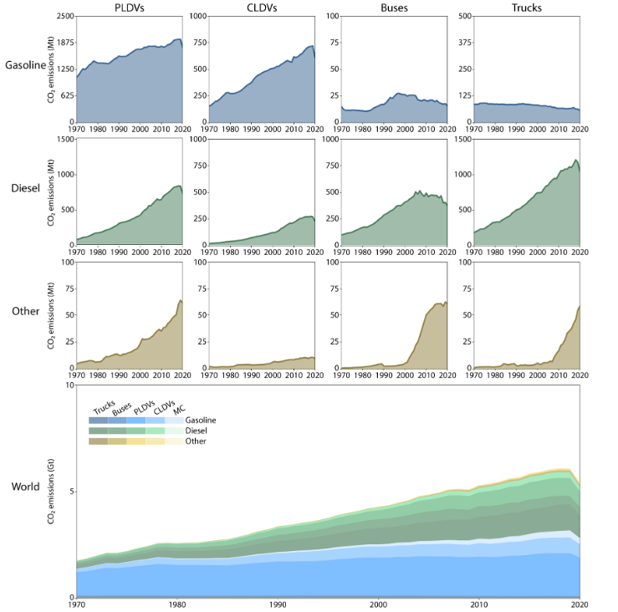

Figure ‑: Global CO2 emissions from 1970 to 2020, grouped by vehicle and fuel type [2]

In addition to contributing significantly to climate change, ICE vehicles are also major sources of air pollutants such as fine particulate matter (PM2.5), which poses serious risks to human health. Despite individuals spending only a fraction of their time in traffic, their exposure to harmful emissions during this period is disproportionately high, especially in congested urban environments. These health impacts translate into substantial societal costs in the form of healthcare expenses. While many regions are implementing stricter emission policies, the continued reliance on ICEs remains a significant barrier to improving air quality and public health [3]. This further underscores the urgency of developing cleaner, more efficient alternatives, such as electric vehicles-supported by scalable manufacturing technologies.

## Vision

The shift to electrification is not only about changing the energy source, it demands a complete rethinking of how these systems are designed and built. The manufacturing of electric motors, though less complex in moving parts than combustion engines, introduces new challenges in precision, scalability, and material handling. One such challenge is the insulation of stator slots, a critical step that influences motor performance, reliability and safety. To meet the increasing demand for high-quality motors at scale, automation of this process is essential. This project contributes to the broader vision of smart manufacturing by addressing one such bottleneck.

## Problem Statement

The goal of this project is to automate a specific step in the assembly of a pre-manufactured stator, namely, the robot-assisted insertion of slot liners into the stator slots. Currently this process is done manually, especially for small batch sizes. The core focus of this thesis is the development of a tool that enables reliable and repeatable insertion of the slot liners. Furthermore, the functionality and performance of the system will be optimized and validated within an automated robotic setup.

## Structure of the thesis

This thesis is structured into eight chapters. Chapter 1 introduces the motivation, vision, and the specific problem addressed in this work. Chapter 2 presents the theoretical background and reviews the current state of the art in motor manufacturing, slot liner insertion, and robotics. Chapter 3 provides an overview of the hardware components used for testing and validating the proposed parametric tool, while Chapter 4 focuses on its design and key features. Chapter 5 describes the implementation process, detailing the applied methodology, and a critical discussion of each step. Chapter 6 addresses the validation process and success rate of the tool based on multiple trials conducted. Finally, Chapters 7 and 8 present the results and offer an outlook on future developments.

# Fundamentals of Electric Motor Production

Electric motors are fundamental components in a wide range of applications, and their production is undergoing a profound transformation to meet growing demand. While highly standardized and automated processes dominate large-scale production, such as in the automotive sector [4], small-scale and custom manufacturing remains prevalent in industries like marine propulsion, where motors are tailored to specific operational requirements [5]. To fully understand the nuances of these production approaches, it is essential to first examine the different motor types and their construction principles, as these directly shape both manufacturing methods and performance outcomes.

## Motor Types and Construction Principes

### Synchronous Motors

### Asynchronous Motors

Squirrel Cage motors

Slip-Ring Motors

## Stator Assembly

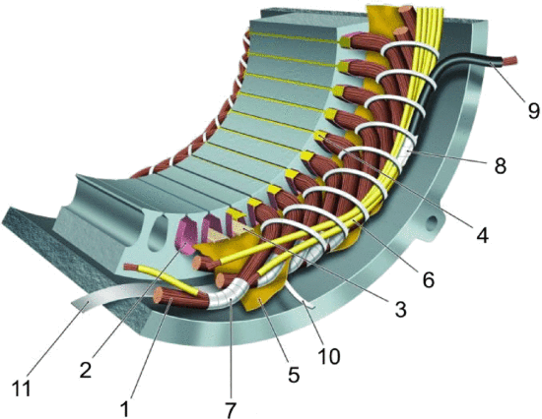

Figure ‑: Overview of insulating and supporting parts in a low-voltage insulation system [6]

The stator core is built from laminated electrical steel sheets, cut via punching or laser processes. These laminations are then stacked and bonded through riveting, welding, or adhesive techniques, to form the magnetic core essential for motor function.The **motor housing** is typically produced using **pressure die-casting** and subsequently machined to ensure surface quality and dimensional precision.

Once the stator core is assembled, several key sub-processes follow. One of the first is the insertion of slot insulation to electrically isolate the windings from the core. This is followed by the winding process, in which copper wire is inserted into the stator slots. Depending on the motor design and production requirements, different winding techniques may be employed, such as linear winding, needle winding, flyer winding, or the pull-in method using pre-formed coils. After winding, the wire ends are insulated, the winding head is formed, and the conductors are interconnected using methods such as crimping, soldering, or suitable welding techniques. The stator is then mechanically stabilized using bandaging and impregnated with resin through processes like trickling, dipping, or vacuum pressure impregnation, to enhance insulation and thermal dissipation. Electrical tests are carried out to verify winding resistance, insulation quality, and overall functionality. [4]. Figure 2-1 shows typical insulation elements in a stator, including 1 turn insulation, 2 slot liner, 3 slot separator,, 6 lead sleeving, 7 coil-nose tape, 8 connection tape, 9 cable, 10 tie cord, and 11 bracing [6]

## Rotor Assembly

The production of electric motor rotors is a sophisticated process that has evolved alongside advancements in materials engineering and manufacturing technologies. At its core, the rotor consists of a laminated steel core to minimize eddy current losses, with construction methods varying according to motor type, most notably between induction machines and permanent magnet synchronous motors (PMSMs). The rotor shaft is formed and machined before being joined with the laminated core, after which the specific rotor configuration is completed based on the motor type. In asynchronous motors (ASMs), a rotor cage is manufactured through pressure die-casting, whereas PMSMs incorporate embedded or surface-mounted permanent magnets. Once assembled, the rotor undergoes precision balancing before the final motor assembly and end-of-line testing, ensuring mechanical and electrical compliance with design specifications. [4]

For induction machines, the “squirrel cage” rotor is prevalent, where the process involves stacking punched or laser-cut steel laminations followed by the insertion or die-casting of aluminum or copper conductor bars and short-circuit rings. The casting method is crucial: controlled solidification ensures optimal electrical conductivity and grain structure for the conducting bars, directly affecting rotor performance and efficiency. This may involve unidirectional cooling and guided solidification to minimize impurities and defects at the grain boundaries.

In the case of PMSMs, rotor fabrication begins similarly with lamination stacking, but then incorporates precise placement of permanent magnets. These magnets may be surface-mounted or embedded within the core, utilizing adhesives, resins, or mechanical fixtures. Advanced research highlights the trend towards additive manufacturing for both the core and fixture components, allowing for integrated cooling channels and custom geometries—particularly important in high-performance applications like aerospace, where power and torque densities are paramount. The use of selective laser melting and other 3D-printing techniques can bring additional functionality, such as enhanced cooling directly at the magnet interface, and enable designs unattainable with traditional methods.

After core assembly and magnet integration, rotors must be meticulously balanced through static and dynamic procedures to ensure smooth operation at high speeds. Modern processes may include in-situ rotor magnetization, where the fully assembled rotor is polarized using a pulse magnetizer to improve handling and safety during assembly. The final steps involve comprehensive testing: checking for geometric precision, rotor imbalance, and verifying the magnetic properties align with design specifications.

These approaches reflect the convergence of established practices—such as controlled die-casting for induction rotors—with emerging technologies like additive manufacturing, which together support greater flexibility, reduced material waste, and higher efficiencies as demanded by today’s electric vehicle and industrial drive sectors.

## Slot liner function and Importance

One of the most critical and delicate steps in stator manufacturing is the **insertion of slot insulation**, often in the form of **slot liners**. These components serve two essential functions: they electrically isolate the stator windings from the core and contribute to **thermal management** by enabling heat dissipation from the windings. Especially in low-voltage electric motors, the slot liner must balance **high dielectric strength** with **thermal conductivity**. Material selection is therefore crucial, as improved thermal performance can directly enhance motor efficiency and longevity. [7]

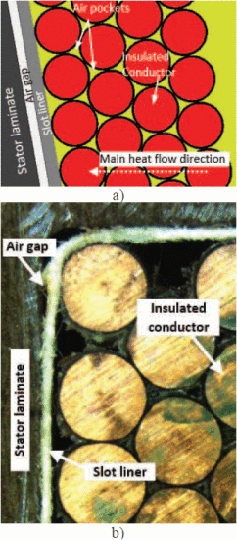

Figure ‑: Stator slot in (a) detail model (motor-cad) and the (b) actual stator slot [8]

In particular, the thermal management role of the slot liner is heavily influenced by how heat flows through the stator slot. Fig 2-2. illustrates the direction of the heat flow, which is from the middle of the slot to the laminate, passing through several layers of winding and the slot liner. A major challenge in this path is the interface air gap between the liner and the laminate, particularly at the rounded corners of the slot, where geometric mismatches increase thermal resistance. This interface gap acts as a thermal barrier, impeding effective heat dissipation. However, proper impregnation techniques can mitigate this issue by filling the gaps, thereby improving thermal contact and overall heat transfer. Consequently, key factors influencing slot thermal performance include the air gap at the liner-laminate interface, the thermal properties of the slot liner material, and the effectiveness of impregnation [8]

Due to the **precision and repeatability** required in the insertion process, manual insertion is often inconsistent and time-consuming. Errors in this step can negatively affect motor performance or lead to failure, which makes **automation** of slot liner insertion an attractive and increasingly necessary solution.

# Robotic Systems for Insertion Tasks

In industrial automation, robots are programmable machines capable of executing a wide variety of tasks with high speed, precision, and repeatability. Their adoption has transformed manufacturing environments by automating repetitive or complex processes, thus enhancing productivity, improving safety, and ensuring consistent product quality. The flexibility of modern robots allows them to adapt to diverse product designs and fluctuating production volumes, which is particularly valuable in applications such as stator assembly, where tasks like slot liner and winding insertion demand both accuracy and adaptability.

### Suitable Robot Types

Modern industrial automation relies on a diverse array of robotic systems, each tailored to specific tasks and operational environments. Among the most prevailent are Articulated robots, SCARA robots, Cartesian and Delta robots. Articulated robots are described as robotic arms with multiple rotary joints, often resembling a human arm, which allows them to perform a wide range of movements and tasks such as welding, assembly, and material handling. Selective Compliance Assembly Robot Arm (SCARA) robots, characterized by three revolute and one prismatic degree of freedom, have become a mainstay in packaging and assembly line automation.These robots are now commercially availabe in a wide range of sizes, linear speeds, and payload capacities to suit diverse industrial needs. While their control systems are typically optimized for standard industrial operations, these configurations often lack the flexibility required for advanced research applications. Cartesian robots, also known as gantry robots, move linearly along three perpendicular X, Y and Z axes, and are commonly used in applications that require straight-line movements such as CNC machine operations and automated drawing or cutting. Delta robots are constructed with lightweight, parallel arms connected to a fixed base, enabling extremely fast and precise movements; they are especially suited for high-speed sorting and packaging tasks. Fig 2-7 illustrates the different robot configurations. [9–13]

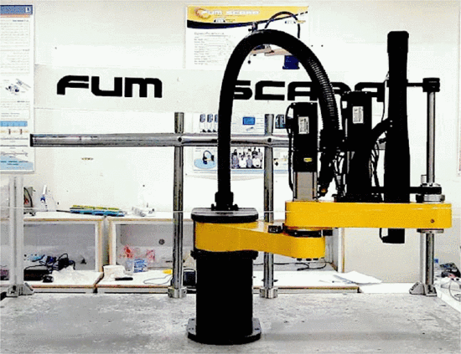

Fig.2-7 (a) SCARA Robot [23]

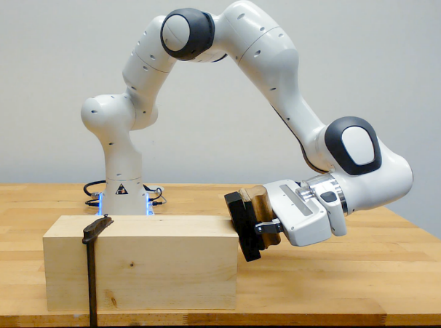

Fig 2-7 (b) Articulated robot [24]

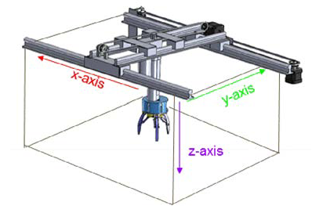

Fig 2-7 (c) Cartesian Robot [26]

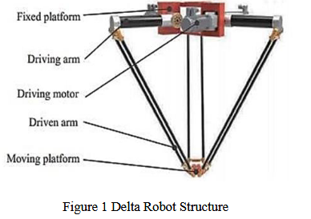

Fig 2-7 (d) Delta Robot [25]

Figure ‑: Examples of common industrial robot configurations used in manufacturing and automation.

Collaborative robots, or cobots, which are designed with advanced sensors and safety features to work alongside humans without the need for safety cages, are increasingly used for flexible automation in environments where human-robot collaboration is beneficial. Each robot type is engineered with specific kinematic structures and control systems, allowing them to excel in particular industrial roles and adapt to the evolving demands of modern manufacturing. In this project, a UR10e robot is utilized as the collaborative robot of choice. As a cobot, the UR10e offers several distinct advantages in flexible automation settings. Its advanced safety features, including integrated sensors and force-limiting technology, enable it to work safely alongside human operators without the need for traditional safety cages. This not only enhances workplace safety but also allows for more efficient use of floor space. Additionally, the UR10e is designed for ease of use, featuring an intuitive programming interface that enables quick setup and redeployment for a variety of tasks. Its flexibility and adaptability make it ideal for environments with evolving production requirements, while its ability to automate repetitive or ergonomically challenging tasks helps improve overall productivity. By integrating the UR10e cobot, the project benefits from increased efficiency, enhanced safety, and the ability to quickly adapt to changing manufacturing demands.

### Kinematics and Motion Control Principles

Kinematics and motion control are foundational to the operation and effectiveness of collaborative robots such as the UR10e. Kinematics refers to the mathematical and geometric study of a robot's movement, focusing on the relationship between joint parameters and the position and orientation of the end-effector, without regard to the forces involved. In the context of the UR10e and similar cobots, both forward and inverse kinematics are essential: forward kinematics calculate the end-effector's position from given joint angles, while inverse kinematics determine the necessary joint angles to reach a desired position and orientation in space. [14]

Building upon the understanding of forward and inverse kinematics, Universal Robots' UR10e utilizes the Denavit–Hartenberg (D-H) convention to systematically model each of its six revolute joints. This modeling framework enables the formulation of transformation matrices that map joint space coordinates to Cartesian space, which is crucial for precise motion planning and real-time control. The D-H parameters define the spatial relationship between links, allowing for calculated transitions between various positions and orientations required during collaborative tasks [15]. The calculation of DH parameters in a UR robot is illustrated in Fig 2-8.

Figure ‑: DH parameter calculation in a Universal Robot [28]

Motion control in the UR10e combines these kinematic models with robust feedback mechanisms and trajectory planning algorithms. Typically, users command the robot via waypoints and trajectory definitions within the programming environment, with the robot’s low-level controller executing the appropriate joint movements to interpolate smoothly between points. The UR10e is fundamentally a position-controlled robot, its built-in controllers accept position and velocity setpoints, rather than torque commands, which means the system emphasizes accuracy and safety, making it well-suited for collaborative environments.The effectiveness of these kinematic and control principles is further enhanced by the UR10e’s modular design, extensive joint ranges, and safety features like collision detection and force limits. The combination of precise kinematic modeling and advanced motion control forms the foundation of the UR10e’s reliability, flexibility, and user-friendly operation in diverse collaborative applications. [16]

### End Effector Requirements

The requirements for end effectors in robotic insertion tasks are shaped by the need for precision, adaptability, and safe handling of often delicate or varied components. For such tasks, the end effector must ensure positional accuracy and repeatability, minimizing insertion forces to protect both the components and the robot. Research highlights the importance of compliance, either through mechanical design or sensor feedback, to accommodate minor misalignments or uncertain tolerances, which is especially significant in operations like slot liner insertions for small-batch, high-variant manufacturing. The end effector design can thus incorporate passive compliance or active sensing (vision, tactile, and force/torque sensors) to enhance performance and reduce the risk of damage or failure during automated assembly. Additionally, modularity and flexibility are crucial: end effectors must often be quickly reconfigurable or compatible with a range of tools to support the diversity encountered in low-volume, customized production environments. Sensors integrated within or attached to the end effector should also support real-time monitoring and adaptive control, key factors in boosting insertion success rates and advancing automation reliability for sensitive handling tasks. [17, 18]

## Sensors and Actuators in Robotic Insertion Tasks

From the requirements described in the previous sections, flexibility and ease of configuration are crucial to meet the current state of the art in low volume, high variance production environments. The choice of actuator is crucial: industrial robots and Cobots are well suited for these tasks due to their inherent flexibility in terms of size and motion, their cost efficiency compared to specialized machines and their ability to work with standard end effectors such as grippers. This section provides an overview of the typical actuators and sensors used in robotic insertion tasks. It introduces various types of electric grippers suited for precision handling, discusses the role of actuators and compliant control, and explains the importance of sensor integration, especially force-torque sensors, for achieving consistent and reliable insertion. Safety and human-robot interaction considerations in such systems are also addressed.

### Electric Grippers for Precision Handling

Electric grippers are among the most versatile and widely adopted end effectors in modern robotics, especially valued for their ability to deliver precise, repeatable, and programmable manipulation of objects in automated tasks. These devices come in numerous configurations, each tailored to address the diverse requirements of precision handling and insertion processes encountered in industrial and collaborative environments. The most common type is the parallel jaw gripper which employs two jaws that move synchronously to grasp objects with consistent force control and high positional accuracy, making it ideal for handling components with uniform geometry such as circuit boards or machined parts. [19]

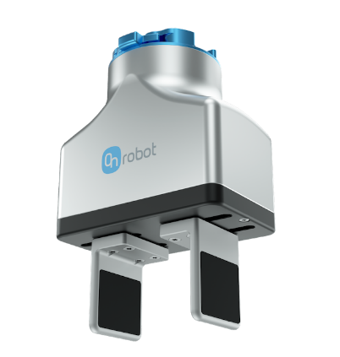

Fig 10 (a) Parallel jaw grippers

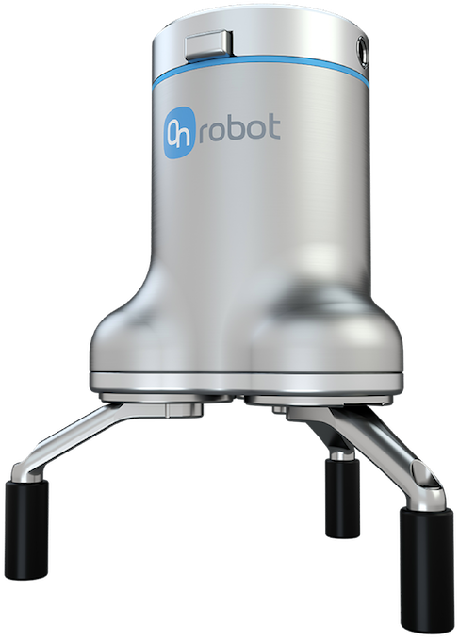

Fig 10 (b) Three Finger Grippers

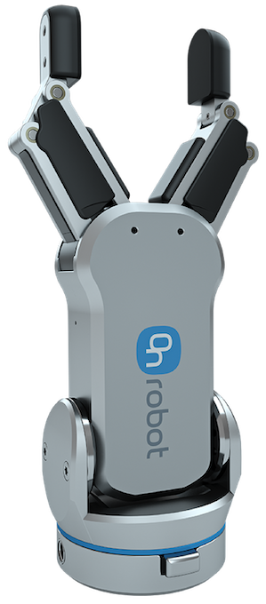

Fig 10 (a) RG2 Gripper

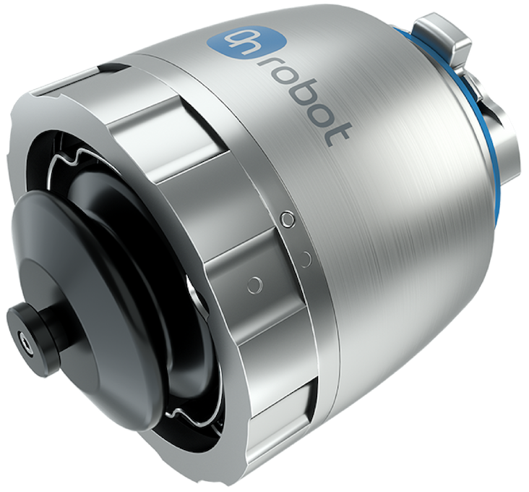

Fig 10 (c) Soft Electric Gripper

Figure ‑: Different Gripper configurations provided by OnRobot [33]

Another prevalent design, the three-finger or centric gripper, uses a radial jaw arrangement to offer self-cantering and secure grasping of round or cylindrical items like pipes, bearings, or fasteners, ensuring stability during manipulation. Some electric grippers include built-in rotary axes, allowing them not only to grip but also rotate workpieces for orientation adjustments without additional arm movement, which improves operational efficiency in complex assemblies. For delicate or variably shaped parts, adaptive and soft electric grippers have emerged. These models use fingers with flexible or compliant material, sometimes powered by unique mechanisms such as tendon drives or shape-memory alloys to conform gently to irregular geometries, thus preventing damage during handling and adapting seamlessly to high-mix, low-volume production setups. Wide-stroke grippers extend this versatility further by accommodating larger or differently sized parts, supporting applications where component variability is high and downtime for changeover must be minimized. In collaborative workspaces, electric grippers designed for safety integrate features like force and speed limitation, smooth profiles, and compliance with international safety standards, allowing them to operate safely in proximity to human workers. [20–22]

### Role of actuators in Slot Liner Insertion

In robotic slot liner insertion, actuators form the backbone of all mechanical movements, enabling precise positioning, handling, and insertion of the slot liner into the stator slots. The robotic manipulator, such as the UR10e used in this project, relies on integrated servo actuators to achieve accurate, multi-axis motion. These actuators are responsible for carrying out trajectory planning, adjusting the insertion angle, and maintaining the correct force and speed during the operation. The end-effector equipped with an electric gripper, relies on fine motor control to grip and manipulate the slot liner without damaging or deforming it. This requires a delicate balance between firmness and compliance, especially due to the liner’s flexibility and the tight tolerances of the stator slots. [23]

However, achieving high precision in insertion tasks is not solely dependent on actuation. The presence of unexpected resistances, alignment mismatches, or minor positional deviations during real-world operation necessitates real-time feedback. To address these challenges, actuators must work in close coordination with sensor systems that monitor force, torque, and position. This interplay between actuators and sensors is especially critical in ensuring compliant control, a capability that allows the robot to respond adaptively to contact forces during insertion, reducing the risk of jamming or material damage. Thus, the effectiveness of the actuator system in slot liner insertion is greatly enhanced through integration with advanced sensing technologies, which are discussed in the following sections.

### Overview of Sensors in Automation

In modern automation systems, sensors serve as the fundamental building blocks of intelligence, acting as the eyes and ears of machines. They are responsible for capturing real-time data from the physical environment, which is essential for ensuring accuracy, repeatability, and adaptability in automated operations.They convert physical phenomena, such as measuring temperature in a furnace or detecting the position of a robotic arm, into electrical signals that can be interpreted by control systems such as PLCs or industrial computers.

By providing continuous feedback, sensors enable closed-loop control systems where real-time decisions can be made to adjust operations dynamically. This not only improves efficiency and safety but also allows for predictive maintenance and reduced downtime. As automation evolves towards greater complexity and autonomy, the demand for reliable, precise, and intelligent sensing technologies continues to grow. Depending on the specific application and the nature of the variable to be measured, a wide range of sensors are utilized in industrial environments. These can be broadly classified into categories based on the type of input they measure, such as proximity, pressure, temperature, force, or optical signals.

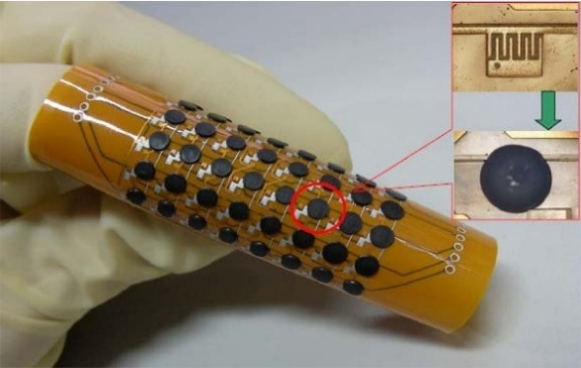

Fig 2-10 (a) Flexible Temperature sensors [38].

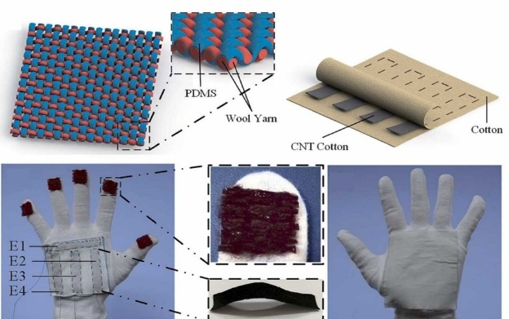

Fig 2-10 (b) Triboelectric flexible proximity sensor [40]

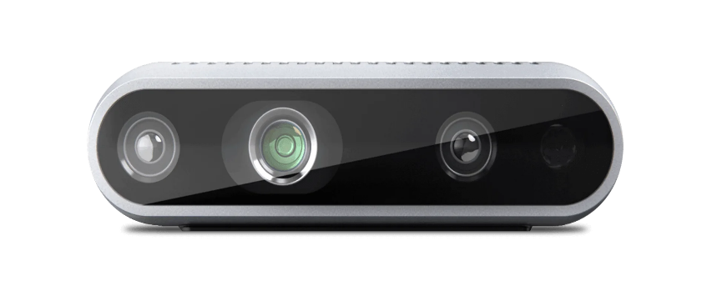

Fig 2-10 (c) Intel Realsense camera [39]

Figure ‑: Various sensors used in automation

In modern automation systems, a select range of sensor types forms the backbone of process monitoring and adaptive control. Temperature sensors, such as thermocouples and Resistance Temperature Detectors (RTDs), are widely deployed to maintain optimal operating conditions and safeguard equipment or product quality by continuously measuring and regulating process temperatures. Optical sensors use light to detect and measure changes in their environment, enabling fast and precise detection without physical contact. They are widely used in industrial automation for tasks like object detection, distance measurement, and quality control. An example of an advanced optical sensor system is the Intel RealSense camera illustrated in fig 11(c), which combines depth and visual imaging to provide detailed 3D data, supporting automated inspection and object recognition in modern manufacturing and robotics. [24–26]. Proximity sensors, including inductive and capacitive variants, enable non-contact detection of objects or machine components, forming the foundation for functions like robotic positioning, presence check in assembly lines, and operational safety interlocks.Triboelectric proximity sensors, Fig 11 (b), leverages the triboelectric effect to achieve self-powered, highly sensitive detection of nearby objects, expanding possibilities in applications such as smart robotics, gesture control, and wearable electronics [27]. Of particular interest in advanced robotic applications are force-torque sensors, typically mounted between a manipulator and its end-effector. These devices precisely measure the forces and torques experienced during manipulation or assembly, providing real-time feedback that allows robots to adapt to subtle variations, avoid excessive loads, and ensure gentle, accurate handling, especially important in tasks like delicate insertion processes. Together, these sensors deliver the critical feedback that enables high-quality, robust, and flexible automation, meeting the challenges of modern manufacturing’s growing need for adaptability and precision.

### Force-Torque Sensors for compliant control

Force-torque sensors are essential components in modern robotics and automation, enabling compliant control during a variety of tasks that require delicate manipulation, precision, and adaptability. These sensors are typically mounted between a robot’s manipulator and its end-effector, providing real-time measurements of both linear forces and rotational torques along multiple axes. Their primary function is to give robots the ability to “feel” their environment, much like the sense of touch in humans, by detecting even subtle contact forces during task execution. These sensors also facilitate compliant control, in which robots dynamically adjust their position and the amount of force applied, based on direct feedback from the environment. This ensures safe and adaptive interactions with objects or surfaces, reducing the risk of damage during tasks such as assembly, insertion, polishing, or when collaborating with humans. For example, during a precision insertion process like slot liner insertion, force-torque sensors enable the robot to sense misalignment and correct its approach in real time, minimizing insertion errors and ensuring gentle handling. [28]  
Technologically, most force-torque sensors rely on strain gauges or piezoelectric elements mounted on a compliant structure. As forces are applied, these elements deform slightly, producing electrical signals that are calibrated and interpreted by the robot’s controller. Sensors are manufactured to measure up to six degrees of freedom (three forces and three torques), which is essential for complex, contact-rich tasks in advanced manufacturing, automated assembly, and surface finishing. The integration of these sensors enables features such as rapid collision detection, skillful manipulation of fragile items, and enhanced safety when robots work alongside humans, as the sensors can trigger immediate corrective action in the presence of unexpected resistance or contact [29]. FT sensor mounted on a UR robot is illustrated A close-up of a robotic arm
in Fig 2-11.

Figure ‑: Force Torque Sensor with gripper installed on a Robotic arm [42]

### Safety and Human Robot Interaction

As robotics and automation systems increasingly operate alongside human workers, the focus on safety and effective human-robot interaction (HRI) has become paramount. Safety in HRI aims to ensure that robots can collaborate with humans without posing risks, relying heavily on technological and regulatory frameworks. Robotic safety is achieved through the integration of advanced sensor technologies such as those mentioned in the previous sections, that allow robots to detect human presence, predict or monitor movement, and respond appropriately in real time. These sensors enable critical functionalities like workspace monitoring, adaptive speed and force control, and collision avoidance, thus preventing injuries and facilitating smooth cooperation. For example, modular sensing systems that combine tactile and proximity sensing have proven effective in both collision avoidance and cooperative guidance, allowing robots to adjust behavior dynamically depending on human actions. An example of a Human Robot Collaboration task is illustrated in Fig 2-12. [30, 31]

Figure ‑: Results of human–robot collaboration experiments. (a) and (b) depict human task coordination by visual detection of the left wrist (handLeft), for halting the robot and performing manual assembly actions (a), followed by right wrist detection (handRight) [44]

International standards further enhance safety in collaborative workspaces. The ISO/TS 15066:2016 specification provides the key framework for designing and assessing the safety of collaborative robot systems. It sets requirements for the collaborative workspace, establishes maximum allowable levels of force and pressure for physical contact, and outlines robust risk assessment practices for various collaborative modes such as safety-rated monitored stop, hand guiding, speed and separation monitoring, and power and force limiting. Compliance with ISO/TS 15066 ensures that robots are designed and integrated with features that mitigate risks, thus supporting trustworthy human-robot collaboration [32].

With robust safety frameworks and advanced sensor integration laying the foundation for effective human-robot collaboration, the next critical element in modern automation is the method by which robots are programmed to perform their tasks. The choice of programming methods not only determines how robots interact with their environment and human coworkers but also directly influences their flexibility, intelligence, and ease of deployment within automated systems. The following section explores the various programming techniques used in robotic automation, highlighting how these approaches enable precise, adaptable, and efficient robot operation in increasingly complex industrial environments.

## Programming Methods in Robotic Automation

Programming methods play a pivotal role in defining how robots are configured, controlled, and optimized for various tasks within automation systems. As robotics technology has advanced, so too have the techniques used to instruct robots, which ranges from manually guided inputs to intelligent, adaptive programming environments. These methods serve as the foundation for enabling precision, consistency, and scalability in automated processes. The choice of programming approach can significantly impact system flexibility, integration effort, and overall efficiency. This section explores the key programming paradigms used in robotic automation and examines how they have evolved to meet the increasing demands of modern manufacturing, logistics, research, and service applications.

### Programming Using Teach Pendant and Manual Inputs

One of the most widely adopted methods for robot programming in industry is **online programming using a teach pendant**. In this approach, often referred to as the **lead-through method**, a skilled operator jogs the robot through the desired path using the pendant, recording specific waypoints that are later converted into motion commands. The operator is responsible for maintaining the robot's pose across all six degrees of freedom (DOF) during this process, which can be especially demanding when the task involves high precision or complex geometries.

Figure ‑: UR Teach Pendant (Insert own image)

While the method offers the advantage of real-time feedback and does not require in-depth coding expertise, it comes with several **critical limitations**. First, the pendant interface is often unintuitive, multiple coordinate frames are defined within the robot system, requiring the operator to constantly track and select the appropriate reference frame. Furthermore, ensuring safe and accurate movements without causing collisions is both time-consuming and mentally taxing. Another significant drawback is the **lack of flexibility and reusability** in the generated robot programs. Even minor variations in the workpiece geometry can require complete reprogramming. Additionally, during the teaching phase, the robot cannot be used for production, reducing overall system efficiency. The quality of the motion paths also varies depending on the operator’s experience and skill level, leading to inconsistencies in task execution. Despite these challenges, this method remains the primary programming choice for small and medium-sized enterprises (SMEs) due to its lower upfront costs and the absence of a need for extensive software tools or external simulation environments. [33]

Teach pendants like Universal Robots' Polyscope not only allow for manual waypoint-based programming but also support the integration of custom script commands via URScript. This adds flexibility and allows for more complex behavior directly within the pendant interface. However, URScript is not limited to pendant use and it can also be executed remotely by sending commands from external applications over a network. This dual use makes URScript a bridge between traditional pendant-based methods and modern, fully automated robot control approaches.

### Implementation of UR Script

UR Script is the core scripting language used for Universal Robots, offering several modes of implementation to accommodate both simple and advanced automation tasks. Through the PolyScope teach pendant, operators can enter or insert URScript commands directly into the robot’s program. This allows blending graphical waypoint-driven teaching with text-based logic, making it possible to add conditional statements, loops, or sophisticated sequencing as needed. The pendant interface offers real-time feedback, program monitoring, and support for debugging, so users can refine URScript commands as they are developed. [34]

Figure ‑: Example of a URScript program to initialize a camera, take a snapshot and retrieve a new target pose [48]

For more integrated and flexible automation, URScript programs can be sent over a network using TCP/IP socket communication. This feature allows external computers, sensors, or higher-level controllers to transmit URScript code for execution, enabling real-time integration with vision systems, adaptive path generation, or manufacturing execution systems. The robot can open sockets, send and receive messages, and dynamically execute motion or I/O based on external data—widely used in advanced manufacturing and system integration. A typical URScript program initializes robot and tool parameters, defines input/output states, and specifies sequences of motion commands with instructions such as movej, movel, or movep. Programs often embed if- statements, loops, and interaction with external devices through I/O or network instructions. PolyScope-generated programs are always converted into URScript before the robot controller executes them, revealing how the script operates as the robot's fundamental control language [35]

The main advantages of URScript include increased programming flexibility, ease of reusing and modifying scripts, and compatibility with both manual and automated workflows. Scripts can be written, versioned, and transferred across different cells or tasks, supporting maintainability and scalability. However, using URScript does present a moderate learning curve, as it requires some familiarity with programming concepts and the robot’s API. Since URScript offers low-level control, scripts must be validated carefully to avoid unintended or unsafe robot behaviour. In summary, URScript bridges the gap between basic waypoint teaching and fully automated, networked robot control. It enables both incremental and transformative advances in factory automation, supporting the evolving needs of modern production environments.

### Programming using ROS

As automation tasks become more interconnected and dependent on external data sources, URScript alone may not offer the flexibility and scalability needed for full system integration. To address these broader requirements, the Robot Operating System (ROS) provides a comprehensive framework for modular robot software development, enabling seamless communication between heterogeneous nodes, external devices, and high-level control logic.

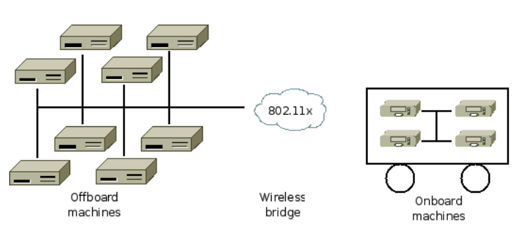

Figure ‑: A typical ROS network configuration [49]

The Robot Operating System (ROS) is a modular, open-source framework designed to simplify the development of complex robotic systems. Rather than functioning as a traditional operating system, ROS provides a flexible middleware layer that enables communication between distributed software components called “nodes”. These nodes interact using a publish-subscribe model via topics for asynchronous messaging or services for synchronous, request-response operations. This architecture promotes modularity and scalability, allowing systems to be assembled from loosely coupled parts that can be modified or replaced independently.

A key strength of ROS is its support for multiple programming languages, including C++, Python, and LISP. Communication between nodes is facilitated through a language-neutral interface definition language (IDL), which enables automatic generation of message-handling code in different languages. ROS encourages the use of standalone libraries for core functionality, keeping the system lightweight and components reusable. To support development, ROS provides a range of tools such as ‘rosbag’ for logging sensor data, ‘roslaunch’ for managing node networks, and ‘rviz’ for real-time visualization, all of which contribute to efficient testing and debugging.

Code in ROS is organized into packages, each containing nodes, configurations, libraries, and launch files. This structure supports collaborative development and version control, making it easy to manage large projects. ROS’s open-source nature and widespread community adoption have led to a vast ecosystem of packages for tasks like perception, control, and planning. By combining modular architecture with powerful development tools and cross-language compatibility, ROS serves as a foundational platform for integrating advanced robotics software in both research and industry. [36]

### Integration of Sensor Feedback

The integration of sensor feedback is fundamental to advancing robotic automation, allowing robots to transition from purely preprogrammed paths to adaptive, intelligent systems. While traditional methods like teach pendant programming and URScript provide a foundation for motion control, and frameworks such as ROS enable flexible software architectures, it is the real-time feedback from sensors that truly empowers robots to interact skillfully and safely with the environment. Sensor feedback bridges the gap between these programming methods by closing the loop between planning and execution, ensuring that robots respond effectively to changing process conditions or uncertainties in the work environment.

Modern robot systems leverage sensor feedback in several ways. On Universal Robots platforms, sensor data can be processed through URScript routines that adjust movement parameters or trigger safety responses when excessive force is detected. ROS further amplifies these capabilities by facilitating seamless integration of sensor data. Nodes within ROS can subscribe to force-torque sensor topics, process signals for filtering or calibration, and implement control algorithms such as force control or impedance control. This modular approach allows developers to combine real-time sensor feedback with higher-level logic such as path planning or AI-driven decision-making. The result is a system where the robot not only follows a taught trajectory but continuously corrects its actions to account for real-world variances and external inputs. In practical deployment, these technologies come together as follows: initial robot paths can be demonstrated and refined via the teach pendant, scripted for deterministic sequence execution using URScript, and further augmented through ROS-based sensor integration for adaptive, situational responses. Force-torque sensors play a central role here, enabling tasks that demand sensitivity or collaboration, such as precise insertion of Slot Liners in Stators, to be reliably automated. This holistic integration of programming interfaces and sensor feedback transforms modern robots into responsive, flexible, and safe collaborators in complex manufacturing settings. [37, 38]

Building on the latest advances in robotic programming, sensing, and automation, it becomes essential to translate these state-of-the-art methods into the actual physical setup required for real-world deployment. The following section focuses on the specific hardware components selected for this project, highlighting how each element has been chosen to meet the precise demands of automated slot liner insertion in electric motor stators.

# Automation of Slot Liner insertion in Motor `Manufacturing

The process of inserting slot liners into stator slots varies widely across different manufacturing scales, from fully automated systems in mass production to manual operations in smaller workshops. This variation reflects the diverse requirements and constraints manufacturers face in balancing cost, flexibility, and quality. In the following sections, different automation solutions are reviewed, along with the fundamental principles guiding their development and implementation in modern electric motor production.

## Common Challenges in the Insertion Process

While large-scale production of electric motors typically involves fully automated processes, it is not economically feasible to implement dedicated machinery for each stator variant in customized small-scale production. Consequently, slot insulation insertion is often performed manually, which introduces several challenges. Quality variations arise due to differences in operator skill and fatigue, leading to inconsistent placement of insulation materials that can compromise motor performance and reliability. Furthermore, the repetitive and physically demanding nature of this task increases the risk of physical strain and injuries among workers, especially when performed over extended periods. These factors, combined with high labor costs in many regions, result in a process that is not only expensive but also inefficient and prone to human error.

To overcome these limitations, this thesis proposes a flexible automation approach that combines a parametric mechanical tool with a general-purpose industrial robot or collaborative robot (Cobot). When equipped with the parametric tool, the robot system can perform slot insulation insertion for a variety of stator geometries without requiring

extensive hardware changes for each variant. This enables a consistent and repeatable process, improving operational efficiency and providing the flexibility required in high-variety, low-volume production environments. At the same time, the system is designed to minimize programming effort and allow for quick reconfiguration between different stator types to ensure overall cost efficiency, especially in high labour cost environments. Potential application scenarios, advantages and limitations of robot-assisted automation solutions have been explored and discussed in previous research work, e.g. Kühl et al. [39], Mahr et al. [40] or Henrich et al. [41]

## Large Scale vs Small Scale Production Strategies

In the context of large-scale electric motor production, the slot liner insertion process is carried out using specialized automation systems designed for precision, speed, and adaptability. Slot insulation machines from manufacturers such as ELMOTEC STATOMAT, NIDE, and Delta Automation Technologies are designed to automate and optimize this process for various stator designs. These machines insert specially shaped insulation paper into the stator slots using a coordinated sequence of creasing, folding, cutting, and inserting. The process guarantees precise alignment and paper overhang, which protects the copper windings from the sharp edges of the laminated core while maintaining a shape conducive to winding insertion. High-speed insertion rates, such as three sleeves per second, are achieved alongside consistent quality, even in small series production. Advanced features like servo-driven feeding, automatic paper forming, programmable interfaces, robotic loading/unloading, and computer-controlled moulds further enhance productivity and flexibility. The machines are engineered for durability, using tempered steel components and stable tubular frameworks, allowing for fast changeovers between stator types and reliable operation with minimal noise and user effort. The technical data-sheet for NIDE slot liner insulation machine is shown in Fig. 2-3. [42–44]

Figure ‑: Technical specifications of NIDE slot liner insertion machine [13]

Despite significant advancements in automation, manual insertion of slot liners remains the standard practice in the small-scale manufacture of electric motors. In such setups, operators typically cut, fold, and insert the slot liners entirely by hand, or use machines for cutting and folding as shown in figure 2-4, while performing the insertion manually with simple jigs. This process relies heavily on visual inspection and tactile feedback to ensure proper alignment However, with the growing demand for electric motors, the need for scalable and streamlined production is increasing. In this context, automation becomes a promising alternative, not because manual methods are ineffective, but because they are difficult to integrate into digital workflows, challenging to scale, and not easily documented for consistent reproduction. [6, 45, 46]

Figure ‑: Adjustable grooving module with two gear-coupled rotating shafts [16]

## Automation Principles

In modern manufacturing, especially for small batch sizes with a high number of variants, automation solutions must be both flexible and economical. A key principle is to transfer repetitive and physically demanding tasks from human operators to automated tools to improve consistency and reduce workload. To remain cost-effective in low-volume environments, such systems should allow easy configuration for new product variants, minimizing programming and set-up efforts. In addition, a modular system architecture-in both hardware and software-allows for incremental expansion and integration of advanced features, such as real-time process adjustments or data-driven optimizations. Stable processes form the basis for reliable production results, while scalability ensures that automation can grow with evolving production requirements. Together, these principles create a framework for the transition from purely manual assembly to flexible and economically sustainable automation in a high variety product field. [47]

### Design for flexible automation

Flexible automation in small batch production requires process designs that can efficiently accommodate frequent changes in product geometries and batch sizes. A key element in achieving this flexibility is parametric tool design, where CAD-based models are defined using parameterized design principles. This approach enables rapid adaptation to different shapes and sizes of stator slots with minimal lead times and low costs, so that tool changes do not become a bottleneck in production. Robots and standard end effectors further contribute to process flexibility, allowing automated systems to perform different tasks without extensive retooling. Modular system architectures create a foundation for future enhancements, such as vision feedback systems or sensor-based adaptations that can improve process reliability and adaptability in real time. Intelligent systems that use digital models, environment-specific knowledge and trajectory-based movement commands support stable and responsive adaptation to variable production scenarios. Finally, scalability remains a key aspect of flexible automation. Even with increasing batch sizes, modular upgrades and reconfigurable system components help to maintain efficiency and make production processes economical. [48]

### Variety in Stator Design for Slot Liner insertion

Electric motor stators exhibit a considerable variety of geometric and structural designs, driven by application-specific performance requirements and space constraints. Key variations include the stator diameter, axial length (stack length), the number of slots, and, crucially, the geometry of the slots and teeth themselves. The majority of stator designs used in low to medium power AC electrical motors feature a parallel-sided tooth, resulting in a trapezoidal slot profile. This configuration enables effective utilization of the stator core material and facilitates the accommodation of windings made from many stranded circular conductors, which can be efficiently fitted into the irregular slot profile. In contrast, an alternative approach, using a parallel-sided slot with a trapezoidal-shaped tooth, is more commonly found in larger distributed wound machines and aircraft generators. The specific configuration of stator slots and teeth has a significant impact on electromagnetic performance, including magnetic flux distribution, core losses, and winding arrangement. Optimizing these shapes is crucial for minimizing losses and improving the magnetic circuit, especially in high-speed or high-frequency applications.

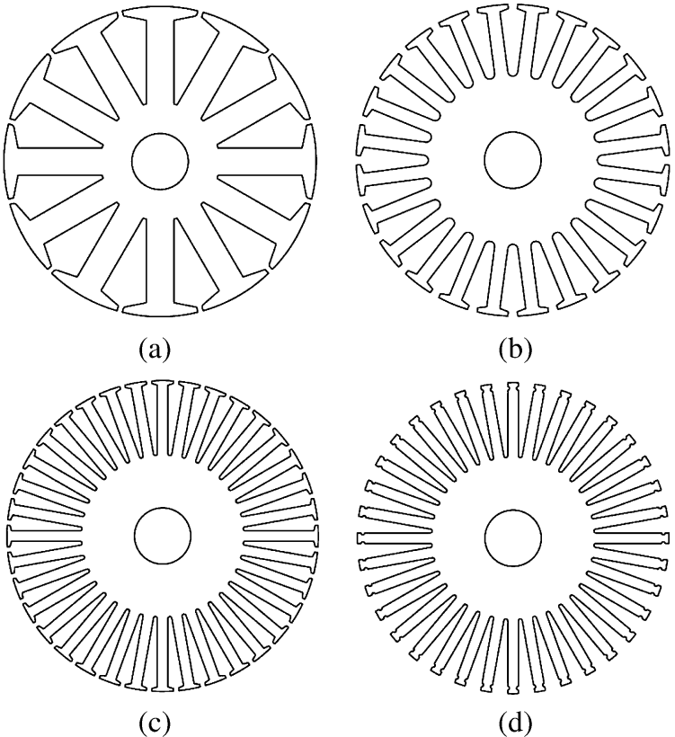

Figure 2‑5: Four typical stator configurations [20]

Furthermore, the choice of slot liner material and its thickness plays a vital role in electrical insulation and thermal management, though it may also affect the available slot area and winding fill factor. Modern design practices often rely on advanced simulation and modeling techniques to balance requirements such as efficiency, torque ripple, noise, and manufacturability, ensuring that the stator slot and tooth geometry is well-matched to the intended application and winding configuration [49, 50] . Different Topologies of the stator such as (a) 12 stator slots. (b) 24 stator slots.(c) 36 stator slots. (d) 36 open stator slots are shown in Fig 2-5.

In view of this wide range of geometries, this paper focuses specifically on medium-sized stators, which are often used in industrial applications and are equipped with U-shaped slot liners. This slot liner shape is widely used in these stators as it provides a reliable balance between mechanical protection of the windings and simple insertion processes. In addition to the U-shaped liners, other common forms of slot liners such as L-shaped configurations are also adapted to specific stator geometries and winding techniques. By focusing on this segment, a clear scope for the analysis and optimization of insertion techniques for slot liners is ensured, while at the same time taking into account the practical challenges of variant management in low-volume production. [51]

### Influence on Insertion tooling and strategies

The geometry of slot liners, particularly the distinction between U-shaped and L-shaped configurations, exerts a significant influence on both insertion tooling and assembly strategies in stator manufacturing. U-shaped liners are often favored for their ease of handling, as their single-piece design is compatible with standard insertion tools, allowing for straightforward and efficient placement into the stator slots. This simplicity supports both automated and manual insertion processes, making U-shaped liners especially suitable for medium-sized stators in industrial applications. In contrast, L-shaped liners, as showin in Fig 2-6 which are typically inserted in pairs to form a complete insulation barrier, may require more precise alignment and specialized tooling to ensure both halves are properly positioned and retained during coil insertion. The presence of features such as reinforced cuffs at the slot edges further affects tooling requirements, as these areas may need additional support or guiding mechanisms to prevent damage or displacement during high-force insertion processes. Moreover, the choice of liner material and thickness also impacts insertion strategies, with thicker or stiffer liners demanding more robust tooling and careful handling to avoid folding or snagging. Ultimately, the selection of slot liner geometry not only shapes the design of insertion tools but also dictates whether fully automated, semi-automated, or manual strategies are most appropriate, particularly in low-volume or highly customized production environments where flexibility and precision are significant. [51]

Figure 3‑4: Cutaway view of a stator slot showing the arrangement of insulation materials and components [21]

# Hardware setup for flexible slot liner insertion

The hardware setup is centered around a modular robotic cell designed to support flexible and precise stator production for electric motors. The stator is mounted vertically in a motor-driven clamp to enable accurate angular positioning of the slots. To support the insertion process, the system also includes dedicated platforms for positioning both the insertion tool and slot liner. Together, these components enable the efficient and smooth insertion of slot liners, forming a cohesive system tailored for reliable and high-precision operation.

## A close up of a robot arm AI-generated content may be incorrect.Robotic Module

The Robotic Module consists of a Universal Robots UR10e Cobot, an OnRobot RG2 Gripper and a HEX Force-Torque (FT) sensor as shown in Fig.3, all coordinated through a central compute box that enables real-time control and adaptability. The Cobot provides programmable motion control, enabling repeatable execution of the insertion tasks. The FT-sensor is mounted on the wrist of the robot for measuring interaction forces during operation. The gripper is attached to the FT-sensor, which allows for secure and flexible handling of the slot liners and funnels of varying sizes and geometries. The robot in combination with the FT-sensor and gripper forms a versatile platform for implementing advanced control strategies, improving insertion accuracy, and handling different stator geometries, typically encountered in small-batch electric motor production.

### UR10e Co-bot

### RG2 Gripper

### HEX Force-Torque Sensor

Sensor-assisted modularity further enhances system performance. The integrated FT-sensor enables real-time monitoring of contact forces during the insertion process, providing valuable force-based feedback to ensure proper positioning and to avoid excessive forces or potential misalignment. This capability enhances the robustness of the system, especially during the initial setup phase Moreover, the presence of the FT-sensor opens possibilities for future development, such as closed-loop feedback control, which could further refine insertion precision under varying mechanical tolerances.

To address the variation in stator designs, the hardware setup incorporates modular and interchangeable tools. Customized tools for guiding slot liners were created using parametric CAD models, whereby rapid adaptation to different motor designs can be achieved by changing just a few core variables. These tools are easily fabricated through 3D printing, which significantly reduces lead time and cost for new configurations.

## Rotating Clamp for Stator Alignment

The stator itself was mounted on a mechanical rotary clamp that could rotate through an angle specified by the user. This rotary mechanism made it possible to adjust the stator incrementally so that each slot was aligned with the funnel after every successful insertion. The rotation step size was configured based on the number of slots in the stator, ensuring the system to perform fully automatic insertions across multiple slots without the need for manual repositioning.

## Tool and Slot Liner Placement Platform

Customized 3D-printed platforms, shown in figure 5, were also designed for the parametric tool and slot liners to ensure secure and repeatable positioning. The tool platform enables reliable and consistent gripping by the robot during each insertion cycle, minimizing alignment errors and improving process stability. Similarly, the slot liner platform held a single pre-folded slot liner in a predefined orientation, enabling precise and repeatable pickup. Although manual reloading was required after each cycle, the secure positioning significantly improved the repeatability and consistency of the entire process.

Fig. 18 Tool and slot liner placement platforms: These platforms enable the robot to consistently and securely grip both the insertion tool and the slot liners for each cycle, ensuring repeatable and reliable operation

# Parametric tool for flexible slot liner insertion

Although general design principles exist for stator slot configurations, the specific geometry is often customized to meet targeted performance requirements such as electromagnetic efficiency, torque output, thermal management and harmonic mitigation. As a result, slot dimensions and shapes can vary depending on the motor’s intended application [15]. For instance, [16] reports stator slots with a height of 30 mm and a slot width of 20 mm. In contrast the stators used in the present study feature smaller dimensions: The first stator has a slot height of 20 mm and a slot width of 8 mm, while the second has a slightly larger slot height of 22 mm. This variation highlights the need for adaptable solutions that can rapidly conform to different geometries to support flexible and efficient insertion of slot liners without requiring extensive manual reconfiguration. To address this problem, a parametric tool designed in the form of a “Funnel” was developed to guide the slot liners into the stator slot. Its design and various views are shown in figure 2.

Fig. 19 Different views of the parametric funnel. The funnel features a tapered internal geometry that guides the slot liner smoothly toward the outlet. The rear view shows the slot profile corresponding to the stator geometry, while the side view highlights the sloped design for insertion. The top view shows the rectangular inlet aligned precisely with the outlet channel.

## Selection of Required Adjustable Parameters

The parameters selected for adjusting the funnel to specific stator configurations, as shown in figure 6, are the slot width, the slot height, and the slot angle. These parameters have a direct influence on the geometry of the funnel, and therefore on the success of the insertion of the slot liner. By determining and adjusting these key dimensions, the insertion tool can be effectively adapted to a wide range of stator topologies. The slot-width governs the base opening and determines the maximum liner width that can be inserted. The slot-height dictates the depth of the slot liner that can be inserted and impacts the structural dimensions of the funnel. Lastly, the slot-angle affects the taper or curvature at the slot entrance, which is critical for guiding the liner during insertion without mechanical interference.

Fig. 20 Key parameters of the funnel design, including slot width, slot height, slot angle, and slot thickness. These parameters define the funnel geometry and limit the allowable dimensions and travel path of the slot liner during insertion

## Fundamental Tool design

### Initial Tool Concept and Design Considerations

### Final Tool Configuration

The funnel serves as a mechanically guided insertion aid positioned between the stator and the gripper during slot liner insertion. It helps shape and align the slot liner, simplifying the process and enhancing insertion accuracy.

The body of the funnel is rectangular in shape with an internal tapered channel that converges towards the stator slot. The inner surface is shaped with two gently curved guiding walls, which direct the slot liner into the correct slot while maintaining central alignment. At the core of the design is a central opening that allows the slot liner to pass through, effectively preventing twisting during insertion. A tapered profile along the insertion path provides slight compression of the slot liner, which helps it retain its shape and improves positioning accuracy as it enters the stator. To ensure vertical alignment, the front face of the funnel includes an inner guiderail that extends towards the stator’s slot profile. This rail serves as a continuous reference surface and guides the liner along the internal geometry of the slot, ensuring consistent insertion height and repeatability. The ends of the rail are tapered to minimize the chance of the slot liner being pulled back with the funnel during retraction.

The rear of the tool also features an external guide rail that helps maintain proper alignment between the funnel and the stator during setup and operation. The grooves on the guide rail, as shown in figure 5, enhance positional locking, ensuring a firm fit and preventing unintentional movement or misalignment during insertion. The funnel inlet is widened to introduce a tolerance margin, accommodating minor misalignments and improving ease of use in practical conditions. The dimensions of the inlet are also parametrically linked to the slot height - as the slot height increases, the funnel inlet automatically scales in size. This preserves insertion reliability across various configurations.

Fig. 21 Grooves on the back of the funnel for proper alignment and locking to the stator slot.

The funnel is lightweight, and 3D printed using Poly Lactic Acid (PLA), a cost-effective material that supports rapid design iterations and economical production for small-scale applications. Design considerations were also made for robotic handling: the side faces are flat with a standard width of 20 mm to facilitate secure gripping. Additionally, the tail of the tool is extended to 50 mm, intentionally shifting the center of gravity rearward, to prevent forward tilting during handling, which could otherwise cause misalignment. To enhance the insertion process, a 1 mm clearance is maintained between the bottom opening of the funnel and the end of the inner-guide rail. This gap allows for smoother slot liner insertion.

The process begins with the robot picking up the funnel from the funnel platform and inserting it into the stator slot. Once positioned, the robot retrieves the slot liner from the platform and inserts it through the funnel into the stator slot. This procedure ensures accurate alignment and reliable slot liner placement.

## Fitting Adjustable Parameters for Specific Use Cases

To validate the adaptability of the parametric funnel design, two stators, both with an outer diameter of 240 mm but different slot geometries, were selected as representative use cases. The first stator has a slot height of 20 mm, while the second has a slot height of 22 mm. The funnel geometry was modified in CAD by adjusting predefined parameters, particularly the slot height. In both cases, the slot height of the funnel was deliberately set slightly lower than the actual stator slot height, to avoid possible interference during insertion. For example, the funnel slot height was parameterized to 19.50 mm for the first stator and 21.50 mm for the second. After the adjustments, the customized funnels were 3D printed and prepared for integration with the robot. These configurations were then used in the validation phase to evaluate the repeatability of the insertion process and the alignment accuracy across both the stators.

# PARAMETRIC SLOT LINER INSERTION PIPELINE

Reliable and flexible slot liner insertion is essential for small-batch electric motor production. To meet this need, a modular automation pipeline was developed. The pipeline was designed with scalability and adaptability in mind. Its parametric nature and sensor feedback implementation allows for quick adjustments to accommodate various stator geometries with minimal hardware or software modifications. By combining mechanical guidance with sensor-assisted control, the setup balances process flexibility, insertion accuracy, and operator safety. The following sub-chapters detail the pipeline architecture, key components, and parametric adaptability.

## Funnel Application

The robot picks up the funnel from the designated funnel platform and starts the insertion process. With the help of the FT sensor, it lowers the funnel until its end touches the stator, thus ensuring precise vertical alignment through force feedback. Subsequently, the robot continues with horizontal insertion, bringing slot profiles of the funnel and stator into perfect alignment and positioning the rear end of the funnel firmly against the stator to ensure correct axial placement. The insertion force is continuously monitored, and when a predefined threshold is reached, signaling that the funnel is fully seated, the gripper releases it, completing the process and preparing for the insertion of the slot liner. This method enables repeatable and precise placement of the funnel on a wide variety of stator designs irrespective of the height or width.

## Slot Liner Positioning and Partial Insertion

With the funnel in place, the robot moves to the slot liner platform to pick up a slot liner. It then aligns the slot liner precisely with the funnel inlet and initiates the insertion. The slot liner is pushed in until the gripper contacts the front opening of the funnel, achieving almost three-quarters of the total insertion depth. At this point, the gripper releases the slot liner, which remains partially inserted in the stator slot, with a portion protruding slightly from the funnel’s opening. The robot then retracts to initiate the funnel removal process.

## Final Liner Insertion

Once the partial insertion is completed, the robot regrasps the funnel and retracts it from the stator. After the funnel is fully removed, the robot repurposes it as a pushing tool to complete the liner insertion. By applying gentle forward pressure with the funnel, the robot ensures that the slot liner is fully seated and flush with the stator surface. This final step confirms proper alignment and secure placement of the liner, completing the automated insertion process. The motor-driven clamp then rotates the stator to align the next slot for insertion, enabling continuous and automated processing of all stator slots. The complete slot liner insertion procedure is illustrated in figure 8.A diagram of a flowchart

Fig. 5. Process Pipeline: The slot liner insertion process follows a structured pipeline divided into two main phases. The first focuses on inserting the funnel and the second handles slot liner insertion. The pipeline is repeated in coordination with clamp rotation to insert slot liners into each stator slot.

## UR Script Based Insertion Control

# Tool Process Testing and Validation

To evaluate the effectiveness of the proposed funnel design and automated insertion process, a series of insertion tests were performed on two stators with different geometries - namely, slot height and number of slots. One had a height of 20 mm with 36 slots, while the other had a slot height of 22 mm with 48 slots. For ease of reference, the stator with the slot height of 20 mm is referred to as stator A and the one with the slot height of 22 mm as stator B. The tests used polyester fleece slot liners which were impregnated on both sides. For each stator, the funnel design was parametrically adapted to the respective slot configuration. These customized funnel variants were then produced using 3D printing and integrated into the test setup. The slot angle (85°) and slot width (8 mm) remained the same for both stators, as the inner diameter of the stator changes. After each insertion cycle, the motorized clamp rotates the stator to align the next slot for insertion. For the stator with 36 slots, the clamp rotates in 10° increments, while for the one with 48 slots, it rotates in 7.5° increments.

## A group of green and orange pie charts AI-generated content may be incorrect.Testing results

Fig. 23 Preliminary and optimized trials for stator A and B. Each stator underwent 40 Preliminary trials and 60 Optimized trials.

The reliability and repeatability of the slot liner insertion process were evaluated through a total of 200 insertion tests on the two stators. Both the Stators underwent 100 trials each, which includes 40 preliminary trials and 60 optimized trials. During all tests, the success rates, the occurrence of defects, and the corresponding failure modes were documented. The average process cycle time was measured at 39.8 seconds at 30% speed, despite the lack of path planning or motion optimization.

## Stator A

For stator A, results summarized in figure 9 indicate an improvement in success rate from 80% in the preliminary phase to 97% following the applied process optimizations. A total of eight errors were identified during the preliminary tests. Six of these were caused by the slot liner being pulled back together with the funnel during funnel extraction. The two remaining errors were caused by the improper placement of the slot liner on the insertion platform, which led to misalignment during insertion. An overview of the error distribution can be seen in figure 10.A graph of a bar chart

Fig. 7 Error Frequency and causes in the preliminary trials for stator A. The slot liner being pulled back with the funnel accounted for 6 errors whereas slot liner misplacement caused 2 errors.

To improve insertion reliability and eliminate the observed failure modes, several corrective measures were implemented. Firstly, the insertion procedure was standardized to ensure precise gripping and consistent alignment of the slot liners. Next, the insertion depth was increased by using the inner finger of the gripper to push the slot liner deeper into the funnel before pulling the funnel out. This technique reduced friction when retracting the funnel and improved the overall quality of the insertion. Finally, the funnel removal motion was changed from a continuous pull to a start-stop sequence. Continuous retraction often caused the funnel to become stuck or dislodge the partially inserted liner. In contrast, withdrawing the funnel in small increments reduced the likelihood of the liner being pulled back, thereby improving consistency and success rates.

After implementing these changes, the optimized test runs were carried out, which led to an increase in the success rate from 80 % to 97 %. Although the error of the slot liner being pulled back with the funnel was significantly reduced, it was not eliminated, resulting in a residual 3% error.

## Stator B

Stator B, which has a slightly larger slot height of 22 mm, was also subjected to a total of 100 insertion attempts. The increased slot height results in a slight narrowing at the upper end of the slot, making the insertion process more sensitive to the profile of the slot liner and its alignment. A total of 10 errors were identified in the preliminary tests. Of these, 9 were attributed to improper insertion. During the initial runs, the slot liners often failed to enter the slot correctly, primarily due to the slot liners not conforming to the required slot profile. One additional error occurred due to misalignment of the funnel on the platform; the graphical representation of the errors can be seen in figure 11. Care was taken to ensure that the slot liners remained consistently aligned during each test. A success rate of 77% was achieved in the preliminary tests. A graph with blue bars

Fig. 8 Fig. 11. Error frequency and causes in the preliminary trials for stator B. Poor slot liner profile accounted for the most number of errors.

In the optimized phase, the same improvements as for Stator A, such as discontinuous retraction and deeper insertion with the gripper were applied. Interestingly, the problem observed in earlier tests with Stator A, where the slot liner was pulled back with the funnel during retraction, did not occur at all with Stator B. This may be explained not only by the optimizations made, but possibly also due to the narrower upper part of the slot, which allowed the slot liner to sit more securely and resist displacement when the funnel was retracted. In addition, repeated trials and controlled folding techniques resulted in improved profiles of the slot liner, which played a crucial role in improving insertion performance. The improved geometry and consistent alignment significantly increased the insertion success rate to 97 %, confirming the effectiveness of the optimizations made for the more geometrically constrained slots of stator B.

## Stator C

# Result Discussion

The process for inserting the slot liners was validated on two stators with different configurations: Stator A with 36 slots and Stator B with 42 slots. This means that for each complete stator, either 36 or 42 successful insertions are required to achieve complete slot lining. One of the most important results of this validation was the 97 % success rate in the optimized tests for both the stators, demonstrating a high degree of repeatability and process reliability. Compared to conventional, fully manual insertion methods, the robot-assisted approach offers several advantages.

The robot-assisted assembly significantly reduces labor and associated costs. Once optimized, the automated process also ensures consistent placement performance, thus minimizing the variability and human error that occur with manual operations. Furthermore, the system has demonstrated high flexibility and can be effectively adapted to different stator types without the need for specialized machines for each variant. This adaptability simplifies logistics and reduces investment costs, creating a scalable solution for diverse manufacturing requirements. By minimizing or eliminating manual intervention during placement, this approach increases workplace safety and reduces the risk of operator injury and fatigue. However, a key drawback to the process is the sensitivity of the process to the slot liner’s profile and condition. During the preliminary trials with Stator B, the slot liners were insufficiently pre-folded, leading to several insertion errors due to improper profiles. This highlights the need for either precisely preformed slot liners or a pre-treatment step to ensure uniform geometry prior to robot-assisted insertion.

In terms of cycle time, the process currently runs at a constant duration of 39.8 seconds per insertion operation. It should be noted that no specific optimization of the process, path planning or timing has been carried out. With appropriate motion planning and trajectory optimization, significant reductions in cycle time can be achieved, thereby improving throughput and production efficiency.

In summary, robot-assisted insertion of slot liners using a parametric funnel has great potential as a scalable, flexible, and cost-effective solution. With minor improvements in the preparation of the slot liners and optimization of cycle times, it can serve as a robust alternative to conventional manual methods in stator assembly.

# Outlook

The Parametric slot liner insertion process has proven to be very promising, as it has a high success rate and can be adapted to different Stator types. However, the current system does not automate the entire preparation cycle for slot liners – in particular, grooving, folding, and cutting. By integrating pre-folding tools and a slot lining dispenser mechanism, robustness and consistency could be significantly improved and a fully automated workflow enabled. These additions would reduce dependence on manual preparation steps and improve process reliability, especially when working with non-pre-folded inserts.

To further reduce errors, a simple image-based quality control system could be introduced to verify the alignment and profile of each slot liner before insertion. This could be enhanced by AI-powered vision systems and machine learning, allowing real-time detection of profile deviations or misalignments and dynamic adjustment of insertion paths. Altogether, expanding the system with pre-processing automation, vision-based inspection, and intelligent feedback mechanisms would transform the current setup into a more autonomous, scalable, and efficient solution suitable for industrial applications.

# Bibliography

References

[1] P. Zhao, Z. Li, Z. Xiao, S. Jiang, Z. He, and M. Zhang, "Spatiotemporal characteristics and driving factors of CO2 emissions from road freight transportation," *Transportation Research Part D: Transport and Environment*, vol. 125, p. 103983, 2023, doi: 10.1016/j.trd.2023.103983.

[2] L. Yan, Q. Zhang, B. Zheng, and K. He, "Modeling fuel-, vehicle-type-, and age-specific CO 2 emissions from global on-road vehicles in 1970–2020," *Earth Syst. Sci. Data*, vol. 16, no. 10, pp. 4497–4509, 2024, doi: 10.5194/essd-16-4497-2024.

[3] X. Song and Y. Hao, "Emission characteristics and health effects of PM2.5 from vehicles in typical areas," *Frontiers in public health*, vol. 12, p. 1326659, 2024, doi: 10.3389/fpubh.2024.1326659.

[4] A. Mayr *et al.,* "Electric Motor Production 4.0 – Application Potentials of Industry 4.0 Technologies in the Manufacturing of Electric Motors," in *2018 8th International Electric Drives Production Conference (EDPC)*, Schweinfurt, Germany, Dec. 2018 - Dec. 2018, pp. 1–13.

[5] J. F. Hansen and F. Wendt, "History and State of the Art in Commercial Electric Ship Propulsion, Integrated Power Systems, and Future Trends," *Proc. IEEE*, vol. 103, no. 12, pp. 2229–2242, 2015, doi: 10.1109/JPROC.2015.2458990.

[6] M. Chapman, N. Frost, and R. Bruetsch, "Insulation Systems for Rotating Low-Voltage Machines," in pp. 257–260.

[7] N. Boulanger *et al.,* "Aramid Based Slot Liners for Low Voltage Electric Motor Applications," in pp. 17–21.

[8] S. Y. Goh, J. Wale, and D. Greenwood, "Thermal analysis for stator slot of permanent magnet machine," in *2016 XXII International Conference on Electrical Machines (ICEM)*, Lausanne, Switzerland, Sep. 2016 - Sep. 2016, pp. 2093–2098.

[9] G. Singh and V. K. Banga, "Robots and its types for industrial applications," *Materials Today: Proceedings*, vol. 60, pp. 1779–1786, 2022, doi: 10.1016/j.matpr.2021.12.426.

[10] M. Shariatee, A. Akbarzadeh, A. Mousavi, and S. Alimardani, "Design of an economical SCARA robot for industrial applications," in pp. 534–539.

[11] Chair of Automatic Control, *Robotics.* [Online]. Available: https://​www.ac.tf.fau.eu​/​research/​robotics/​ (accessed: Aug. 1 2025).

[12] D. Seleem, M. A. Shamseldin, and H. Eleashy, "Design and Control of Delta Robot (mini review)," *Future Engineering Journal*, vol. 5, no. 1, 2025. [Online]. Available: https://​digitalcommons.aaru.edu.jo​/​fej/​vol5/​iss1/​2

[13] M. Saadeh and C. Koutsougeras, "DEVELOPMENT OF A CARTESIAN ROBOT WITH IMAGE PROCESSING AND GRASP DETECTION," in pp. 1246–1257.

[14] P. Sanz, "Robotics: Modeling, Planning, and Control (Siciliano, B. et al; 2009) [On the Shelf]," *IEEE Robot. Automat. Mag.*, vol. 16, no. 4, p. 101, 2009, doi: 10.1109/MRA.2009.934833.

[15] Universal Robots, *DH Parameters for calculations of kinematics and dynamics.* [Online]. Available: https://​www.universal-robots.com​/​articles/​ur/​application-​installation/​dh-​parameters-​for-​calculations-​of-​kinematics-​and-​dynamics/​

[16] Universal Robots, *UR10e User Manual.* [Online]. Available: https://​www.universal-robots.com​/​manuals/​EN/​PDF/​SW5\_​19/​user-​manual-​UR10e-​PDF\_​online/​711-​039-​00\_​UR10e\_​User\_​Manual\_​en\_​Global.pdf (accessed: 15-072025).

[17] K. Eshraghi, P. Jiang, D. Suraci, and M. Atherton, "Preliminary Study of End-Effector Compliance for Reducing Insertion Force in Automated Fluid Coupling for Trains," *JID*, vol. 24, 3-4, pp. 139–161, 2022, doi: 10.3233/JID200017.

[18] P. Georgi, S. Ehnert, K. Güzel, and H.-C. Möhring, "Design and simulation of a multisensory-multi-process end-effector for application to various kinematics," *Procedia CIRP*, vol. 130, pp. 915–923, 2024, doi: 10.1016/j.procir.2024.10.185.

[19] M. Guo *et al.,* "Design of parallel-jaw gripper tip surfaces for robust grasping," in *2017 IEEE International Conference on Robotics and Automation (ICRA)*, Singapore, Singapore, May. 2017 - Jun. 2017, pp. 2831–2838.

[20] HITBOT, *Commonly used robotic Grippers.* [Online]. Available: https://​www.hitbotrobot.com​/​commonly-​used-​electric-​grippers/​ (accessed: Jul. 24 2025).

[21] M. Liu, L. Hao, W. Zhang, and Z. Zhao, "A novel design of shape-memory alloy-based soft robotic gripper with variable stiffness," *International Journal of Advanced Robotic Systems*, vol. 17, no. 1, 2020, doi: 10.1177/1729881420907813.

[22] On Robot, *Products and applications.* [Online]. Available: https://​onrobot.com​/​en/​products (accessed: Jul. 24 2025).

[23] *Robotics*: Springer, London, 2010.

[24] V. K. Rai, "Temperature sensors and optical sensors," (in En;en), *Appl. Phys. B*, vol. 88, no. 2, pp. 297–303, 2007, doi: 10.1007/s00340-007-2717-4.

[25] W.-P. Shih *et al.,* "Flexible Temperature Sensor Array Based on a Graphite-Polydimethylsiloxane Composite," *Sensors*, vol. 10, no. 4, pp. 3597–3610, 2010, doi: 10.3390/s100403597.

[26] Intel® RealSense™ Depth and Tracking Cameras, *Depth Camera D435i.* [Online]. Available: https://​realsenseai.com​/​stereo-​depth-​cameras/​depth-​camera-​d435i/​

[27] L. Huang *et al.,* "Research progress of multifunctional flexible proximity sensors," *Sensors and Actuators A: Physical*, vol. 360, p. 114500, 2023, doi: 10.1016/j.sna.2023.114500.

[28] T. Swedberg, "Force Torque Sensors Enhance Robotic Precision and Sensitivity," *JHFOSTER*, 07 Oct., 2025. https://​jhfoster.com​/​automation-​blogs/​force-​torque-​sensors-​enhance-​robotic-​precision-​and-​sensitivity/​ (accessed: Jul. 26 2025).

[29] Bota Systems, *What's a force torque sensor? | Bota Systems.* [Online]. Available: https://​www.botasys.com​/​post/​force-​torque-​sensor (accessed: Jul. 26 2025).

[30] G. Laudante, M. Mirto, O. Pennacchio, and S. Pirozzi, "A multi-modal sensing system for human-robot interaction through tactile and proximity data," *Front. Robot. AI*, vol. 12, p. 1581154, 2025, doi: 10.3389/frobt.2025.1581154.

[31] A. Angleraud, A. Ekrekli, K. Samarawickrama, G. Sharma, and R. Pieters, "Sensor-based human–robot collaboration for industrial tasks," *Robotics and Computer-Integrated Manufacturing*, vol. 86, p. 102663, 2024, doi: 10.1016/j.rcim.2023.102663.

[32] ISO, *ISO/TS 15066:2016.* [Online]. Available: https://​www.iso.org​/​standard/​62996.html (accessed: Jul. 26 2025).

[33] Z. Pan, J. Polden, N. Larkin, S. van Duin, and J. Norrish, "Recent progress on programming methods for industrial robots," *Robotics and Computer-Integrated Manufacturing*, vol. 28, no. 2, pp. 87–94, 2012, doi: 10.1016/j.rcim.2011.08.004.

[34] *Five ways to program a cobot.* [Online]. Available: https://​www.universal-robots.com​/​developer/​five-​ways-​to-​program-​a-​cobot/​ (accessed: Jul. 27 2025).

[35] Universal Robots, *URScript API Reference - scriptManual.* Accessed: Jul. 27 2025. [Online]. Available: https://​s3-eu-west-1.amazonaws.com​/​ur-​support-​site/​69544/​scriptManual.pdf

[36] *ROS: an open-source Robot Operating System*, 2009. [Online]. Available: http://​lars.mec.ua.pt​/​public/​lar%20projects/​binpicking/​2016\_​rodrigosalgueiro/​lib/​ros/​icraoss09-​ros.pdf

[37] A. Cherubini and D. Navarro-Alarcon, "Sensor-Based Control for Collaborative Robots: Fundamentals, Challenges, and Opportunities," *Frontiers in neurorobotics*, vol. 14, p. 576846, 2020, doi: 10.3389/fnbot.2020.576846.

[38] *ROS 2 integration paths — Universal Robots ROS 2 Driver Documentation 0.1 documentation.* [Online]. Available: https://​docs.universal-robots.com​/​Universal\_​Robots\_​ROS2\_​Documentation/​doc/​ros2\_​controller\_​vs\_​driver.html (accessed: Jul. 29 2025).

[39] *Robot-based production of electric motors with hairpin winding technology*, 2019. [Online]. Available: https://​www.iaeng.org​/​publication/​wcecs2019/​wcecs2019\_​pp257-​262.pdf

[40] A. Mahr, P. Mathea, A. Vogel, A. Morello, J. Franke, and A. Kühl, "Robotic based Assembly of insulating Sleeves onto Winding Coil Ends of Electric Drive Stators," in *2023 13th International Electric Drives Production Conference (EDPC)*, 2023, pp. 1–7.

[41] V. Henrich, A. Vogel, M. Baader, J. Franke, and A. Kühl, "Vision-Based Pose Estimation of Superimposed Enameled Wire Ends for Robotic Handling of Powerdense Flat Wire Stators," in *2024 14th International Electric Drives Production Conference (EDPC)*, 2024, pp. 1–9.

[42] Elmotec Statomat, *Slot Insulation - Elmotec Statomat.* [Online]. Available: https://​www.elmotec-statomat.eu​/​en/​manufacturing-​process/​slot-​insulation/​

[43] NIDE, *Automatic Stator Slot Insulation Paper Inserting Machine for Induction Motor Three Phase Motor Winding.* [Online]. Available: https://​salesdpti-nide.en.made-in-china.com​/​product/​SKpnekvGAjWL/​China-​Automatic-​Stator-​Slot-​Insulation-​Paper-​Inserting-​Machine-​for-​Induction-​Motor-​Three-​Phase-​Motor-​Winding.html

[44] Delta Automation Technology, *Slot Insulation Machine.* [Online]. Available: https://​deltasrl.online​/​en/​avada\_​portfolio/​slot-​insulation-​machine/​

[45] BEN Buchele, *BEN Buchele Elektromotorenwerke GmbH in Nürnberg.* [Online]. Available: https://​www.benbuchele.de​/​

[46] D. Mayer, L. Hausmann, N. Maul, L. Reinschmidt, J. Hofmann, and J. Fleischer, "Systematic Investigation of the Grooving Process and its Influence on Slot Insulation of Stators with Hairpin Technology," in pp. 1–7.

[47] Automation International, *Flexibility and Efficiency in Small Batch Production through Automation.* [Online]. Available: https://​www.automation-mag.com​/​news/​91746-​flexibility-​and-​efficiency-​in-​small-​batch-​production-​through-​automation

[48] Y. Koren *et al.,* "Reconfigurable Manufacturing Systems," *CIRP Annals*, vol. 48, no. 2, pp. 527–540, 1999, doi: 10.1016/s0007-8506(07)63232-6.

[49] R. Wrobel, S. J. Williamson, N. Simpson, S. Ayat, J. Yon, and P. H. Mellor, "Impact of slot shape on loss and thermal behaviour of open-slot modular stator windings," in *2015 IEEE Energy Conversion Congress and Exposition (ECCE)*, Montreal, QC, Canada, Sep. 2015 - Sep. 2015, pp. 4433–4440.

[50] L. L. Wang, J. X. Shen, P. Luk, W. Z. Fei, C. F. Wang, and H. Hao, "Development of a Magnetic-Geared Permanent-Magnet Brushless Motor," *IEEE Trans. Magn.*, vol. 45, no. 10, pp. 4578–4581, 2009, doi: 10.1109/tmag.2009.2023071.

[51] The Gund Company, *Generator Slot Liner Selection Guide.* [Online]. Available: https://​thegundcompany.com​/​wp-​content/​uploads/​2024/​03/​Slot-​Liner-​Selection-​Guide-​The-​Gund-​Company.pdf (accessed: Jul. 10 2025).